PROJECT REPORT

CONTENTS OF THE REPORT
- Cover page –
- Declaration
- Certificate
- Acknowledgement
- Table of Contents

1. Introduction
2. Scope of the study (Problem Statement)
3. Existing System
- Introduction
- Existing Software
- DFD for present system
- What’s new in the system to be developed
4. Problem Analysis
- Product definition
- Feasibility Analysis
- Project Plan
5. Software Requirement Analysis
- Introduction
- General Description
- Specific Requirements
6. Design
- System Design
- Design Notations
- Detailed Design
- Flowcharts
- Pseudo code
7. Testing
- Functional testing
- Structural testing
- Levels of testing
- Testing the project
8. Implementation
- Implementation of the project
- Conversion Plan
- Post-Implementation and Software Maintenance
9. Project Legacy
- Current Status of the project
- Remaining Areas of concern
- Technical and Managerial lessons learnt
11. Source Code (where ever applicable) or System Snapshots
12. Bibliography

COVER PAGE

PROJECT REPORT
(Project Term January-May 2026)

(TrackIt – Study Session Monitoring System)

Submitted by

(Rahul Pandey) Registration Number:12316599

Course Code: INT 332

Under the Guidance of

(Dr. Alok Mishra)

School of Computer Science and Engineering


DECLARATION
I hereby declare that the project work entitled TrackIt – Study Session Monitoring System is an authentic record of my own work carried out as requirements of Project for the award of B.Tech Degree in Computer Science and Engineering from Lovely Professional University, Phagwara, under the guidance Dr. Alok Mishra, during January to May 2026. All the information furnished in this project report is based on my own intensive work and is genuine.

Name of Student: Rahul Pandey
Registration Number:12316599

(Rahul Pandey)
Date:29-05-2026

CERTIFICATE
This is to certify that the declaration statement made by the student is correct to the best of my knowledge and belief. He has completed this project under my guidance and supervision. The present work is the result of his original investigation, effort, and study. No part of this work has ever been submitted for any other degree at any University.
The project entitled "TrackIt – Study Session Monitoring System" is fit for submission and partial fulfilment of the requirements for the award of B.Tech Degree in Computer Science and Engineering from Lovely Professional University, Phagwara.

Dr. Alok Mishra

Designation

School of Computer Science and Engineering,
Lovely Professional University,
Phagwara, Punjab.

Date :29-05-2026
ACKNOWLEDGEMENT
I express my sincere gratitude to my project mentor for providing valuable guidance, support, and encouragement throughout the development of this project. Their suggestions and technical expertise greatly contributed to the successful completion of this work.
I also thank the School of Computer Science and Engineering, Lovely Professional University, for providing the necessary facilities and learning environment. Finally, I would like to thank my friends and family members for their continuous motivation and support.
TABLE OF CONTENTS
Inner first page……………………………………………………………………….(i)
Declaration…...……………………………………………………………………..(ii)
Certificate……..…….………………………………………………………………(iii)
Acknowledgement…………………...………………………………………….......(iv)
Table of Contents……………………...……………………………………………(v)

1. INTRODUCTION 1

1.1. SECOND-LEVEL SUBHEADING 1

1.2. ANOTHER SECOND-LEVEL SUBHEADING 1

1.2.1. THIRD-LEVEL SUBHEADING 1

1. INTRODUCTION
TrackIt is a smart study session monitoring system developed to improve academic productivity and learning discipline among students. The application enables students to record and monitor their study activities while allowing teachers, mentors, and parents to track progress remotely.

The system is developed using Flutter, Firebase, Jenkins, Docker, NGINX, Prometheus, and Grafana technologies. Jenkins automates the CI/CD pipeline, Docker provides containerized deployment, NGINX hosts the web application, while Prometheus and Grafana provide monitoring and visualization of application and infrastructure performance.

Objectives

Implement CI/CD using Jenkins.

Automate deployment using Docker containers.

Monitor application and server performance using Prometheus and Grafana.

Improve system reliability and scalability through DevOps practices.

2 SCOPE OF THE STUDY (PROBLEM STATEMENT)
Students often struggle with maintaining study consistency, time management, and self-discipline. Traditional methods such as notebooks and manual records are inefficient and difficult to analyse.
The project aims to solve these issues by providing:
- Digital study session tracking.
- Real-time monitoring.
- Progress analysis through charts.
- Cloud-based data management.
- Performance reporting for students and viewers.

3 EXISTING SYSTEM
3.1 Introduction
Current study tracking methods mainly rely on manual record-keeping and self-reporting, which are time-consuming and inaccurate.
3.2 Existing Software
- Study planners
- Manual notebooks
- Basic timer applications
- Spreadsheet-based tracking systems
3.3 DFD for Present System
Current Flow:
Student → Manual Record → Teacher/Parent Review
Limitations:
- No real-time updates
- No automated analytics
- Difficult progress monitoring
- High chances of inaccurate data
3.4 What's New in the Proposed System
- Real-time monitoring
- Secure cloud storage
- Graphical analytics
- Student-viewer connectivity
- Performance tracking dashboard

4. PROBLEM ANALYSIS

4.1 Product Definition
TrackIt is a study monitoring platform that records study sessions, stores academic activity data, and provides real-time analytics to students and viewers.
4.2 Feasibility Analysis
Technical Feasibility
The project uses Flutter, Firebase Authentication, Firebase Realtime Database, Jenkins, Docker, NGINX, Prometheus, Grafana, cAdvisor, and Node Exporter. These technologies are widely adopted in modern software development and DevOps environments.
Economic Feasibility
Firebase provides affordable cloud services and reduces infrastructure costs.
Operational Feasibility
The application is user-friendly and requires minimal training.
4.3 Project Plan
Phase 1: Requirement Gathering
Phase 2: System Design
Phase 3: Frontend Development
Phase 4: Backend Integration
Phase 5: Testing
Phase 6: Deployment
5. SOFTWARE REQUIREMENT ANALYSIS
5.1 Introduction
Software Requirement Analysis identifies functional and non-functional requirements of the TrackIt system.
5.2 General Description
The system consists of:
- Student Module
- Viewer Module
- Authentication Module
- Analytics Module
5.3 Specific Requirements
Functional Requirements
- User Registration
- User Login
- Session Recording
- Subject Management
- Analytics Generation
- Viewer Monitoring
Non-Functional Requirements
- Security
- Reliability
- Scalability
- Performance
- Availability
Software Requirements
- Flutter SDK
- Dart
- Firebase
- Android Studio / VS Code
- Git & GitHub
- Docker
- Nginx
Additional DevOps Requirements
- Jenkins Server
- Prometheus Monitoring Server
- Grafana Dashboard Server
- cAdvisor
- Node Exporter
6. DESIGN
6.1 System Design

Developer
|
v
GitHub Repository
|
v
Jenkins Pipeline
|
v
Build Flutter Application
|
v
Docker Image Creation
|
v
NGINX Deployment
|
v
TrackIt Application

Monitoring Layer

Prometheus
|
v
Grafana

Metrics Sources:
- Node Exporter
- cAdvisor
- Docker Containers
- NGINX
6.2 Design Notations
Use Case Diagram
Actors:
- Student
- Viewer
Student Functions:
- Login
- Create Sessions
- View Analytics
Viewer Functions:
- Search Student
- Monitor Progress
- View Reports
6.3 Detailed Design
Student Dashboard
- Add Study Session
- Select Subject
- Track Duration
- View Charts
Viewer Dashboard
- Search Student
- Connect with Student
- Monitor Progress
6.4 Flowchart
Start
↓
Login/Register
↓
Student Dashboard
↓
Create Study Session
↓
Store Data in Firebase
↓
Generate Analytics
↓
Display Reports
↓
Logout
↓
End
6.5 Pseudo Code
BEGIN
User Login
IF Authentication Successful
Open Dashboard

Create Study Session

Store Session Data

Generate Analytics

Display Reports
ELSE
Show Error
END IF
END
6.6 Jenkins CI/CD Workflow
Jenkins Pipeline
The TrackIt project follows a Continuous Integration and Continuous Deployment (CI/CD) workflow using Jenkins.
Pipeline Steps:
- Developer pushes source code to GitHub.
- Jenkins automatically detects changes.
- Jenkins builds the Flutter application.
- Docker image is created.
- Docker container is deployed.
- NGINX serves the application.
- Prometheus monitors system health.
- Grafana displays performance dashboards.
Benefits:
- Automated deployment
- Reduced human error
- Faster software delivery
- Continuous monitoring
7. TESTING
7.1 Functional Testing
- Login Validation
- Session Creation
- Data Synchronization
- Analytics Generation
7.2 Structural Testing
- Code Review
- Module Testing
7.3 CI/CD Pipeline Testing
The Jenkins pipeline was tested to ensure:
- Successful code integration
- Automated build execution
- Docker image creation
- Automated deployment
- Monitoring service availability

7.4 Levels of Testing
Unit Testing
Testing individual modules.
Integration Testing
Testing interaction between Flutter and Firebase.
System Testing
Testing complete application functionality.
7.4 Testing Results
All modules functioned successfully without major errors.

8. IMPLEMENTATION
8.1 Implementation
Frontend Layer
- Flutter Web
- Dart
Backend Layer
- Firebase Authentication
- Firebase Realtime Database
CI/CD Layer
Jenkins
Jenkins automates:
- Source code integration
- Build process
- Docker image generation
- Application deployment
Containerization Layer
Docker
Docker packages the application into portable containers for consistent deployment.
Hosting Layer
NGINX
NGINX serves the Flutter Web application and handles incoming requests efficiently.
Monitoring Layer
Prometheus
Prometheus collects:
- CPU metrics
- Memory metrics
- Container metrics
- Server health metrics
Grafana
Grafana visualizes:
- Real-time dashboards
- Infrastructure performance
- Application monitoring reports

9. PROJECT LEGACY
9.1 Current Status
The TrackIt platform has been successfully implemented with a complete DevOps workflow. Jenkins automates the CI/CD process, Docker enables containerized deployment, NGINX hosts the application, and Prometheus-Grafana provide monitoring and observability.
9.2 Remaining Areas of Concern
- AI-based recommendations not yet implemented.
- Notification system can be enhanced.
- Attendance tracking can be integrated.
9.3 Technical and Managerial Lessons Learned
- Flutter cross-platform development.
- Firebase cloud integration.
- Real-time database management.
- Team collaboration and project planning.

10. SYSTEM SNAPSHOTS
Insert screenshots of:
- Login Screen
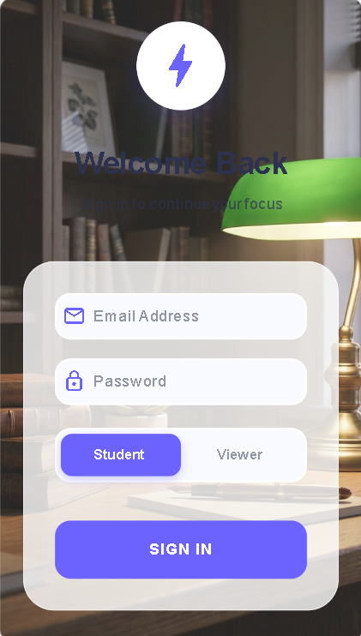
- Registration Screen
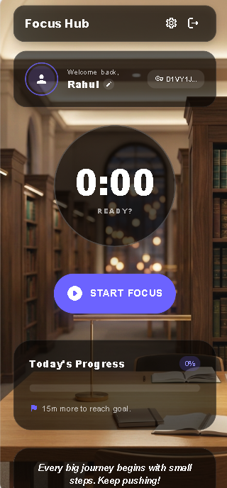
- Student Dashboard

- Viewer Dashboard
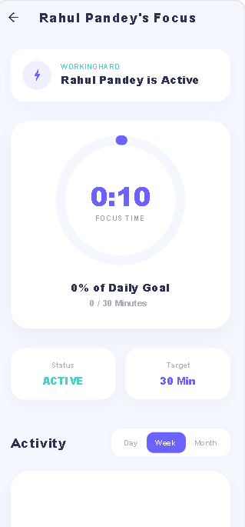
- Jenkins Pipeline
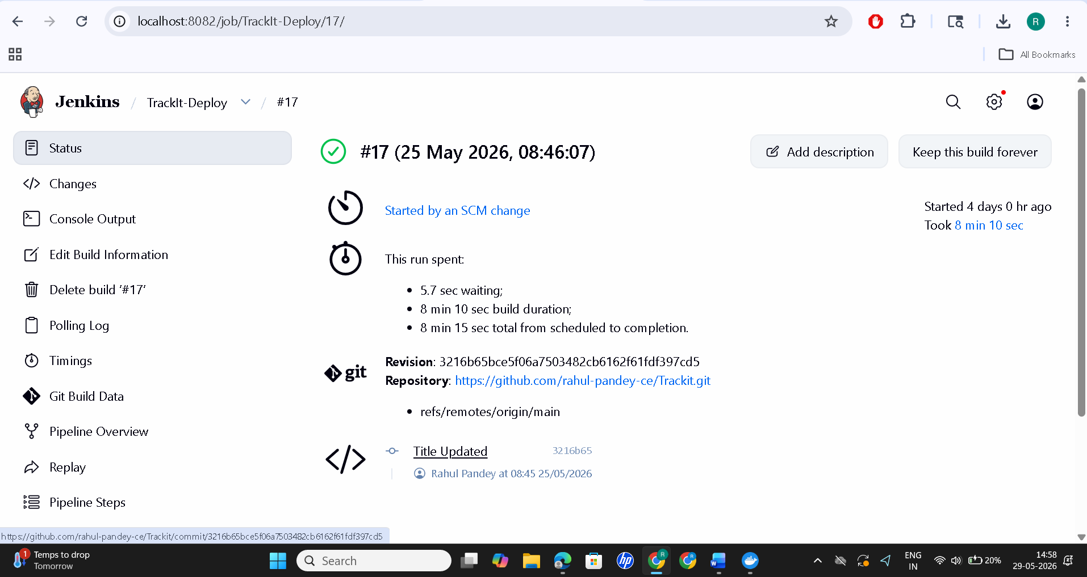
- Grafana
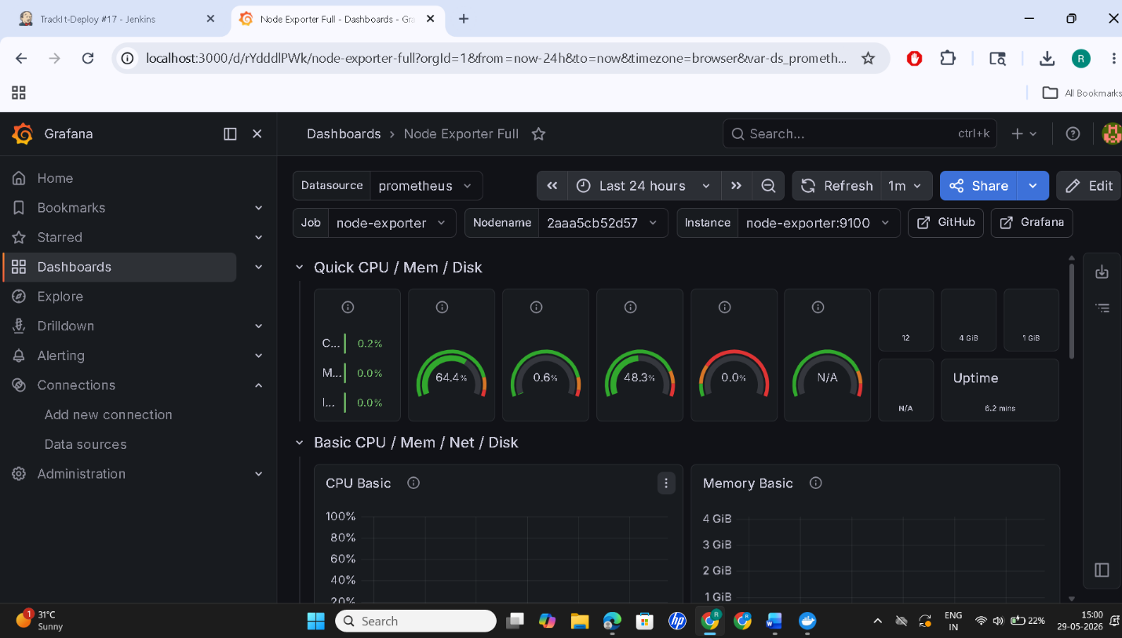

- Monitoring
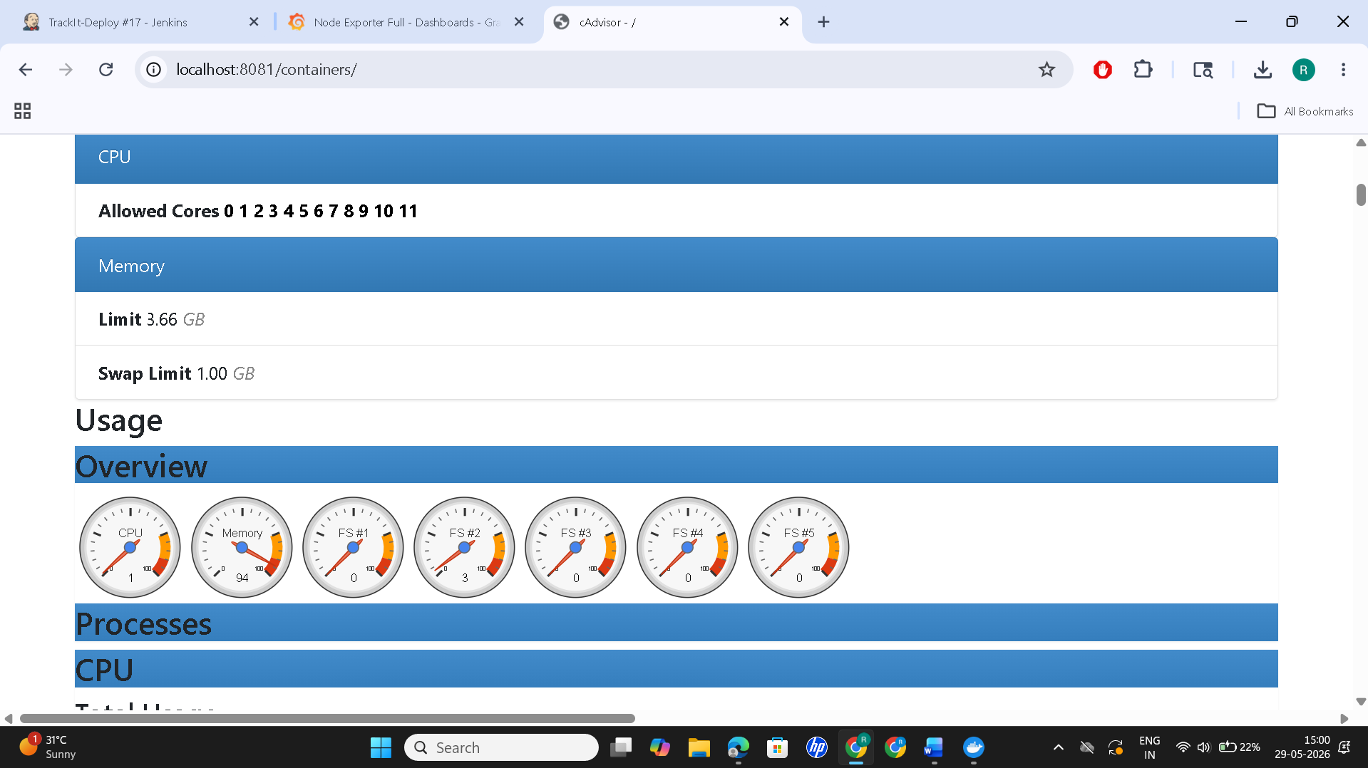

11. BIBLIOGRAPHY
- Flutter Documentation – https://flutter.dev
- Firebase Documentation – https://firebase.google.com
- Dart Programming Language Documentation
- Docker Documentation
- Nginx Documentation
- GitHub Documentation
- Research Papers on Educational Analytics and Productivity Monitoring

